Mantid
PM report to Project Management Board
29th January 2019
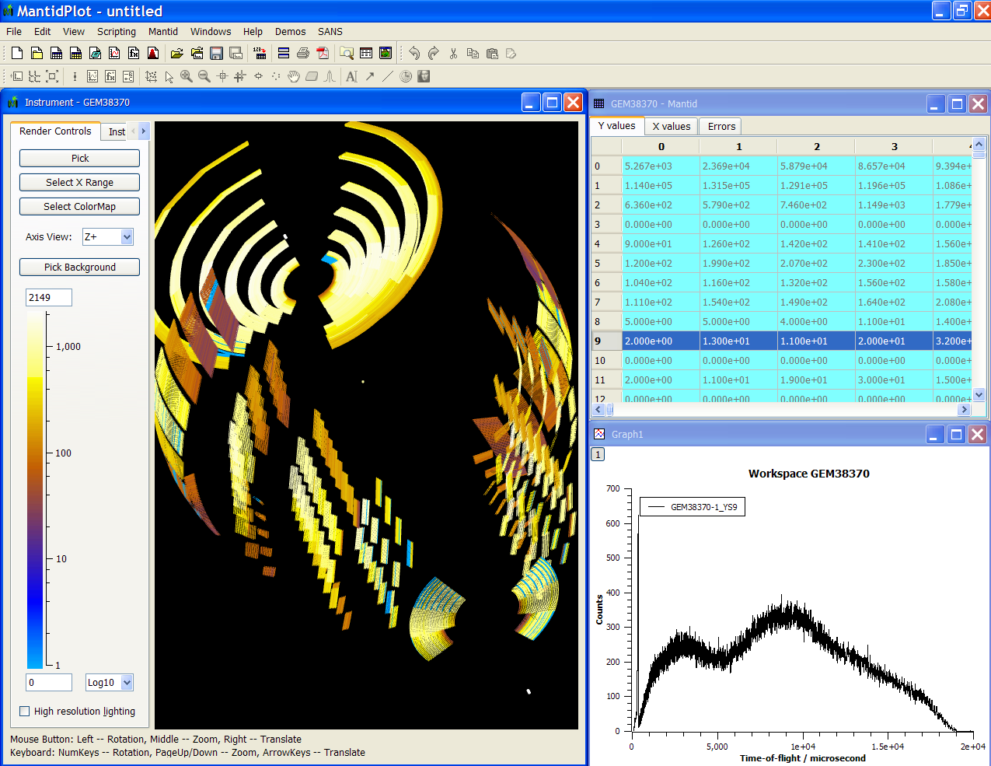
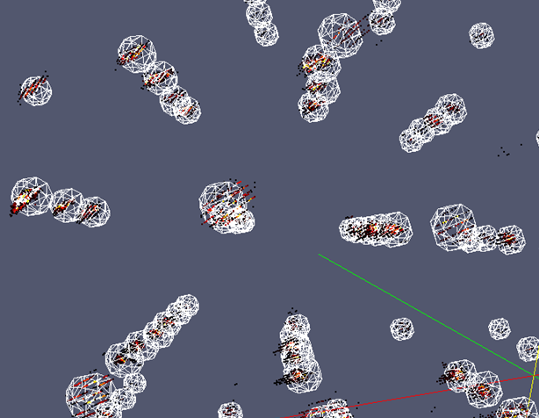
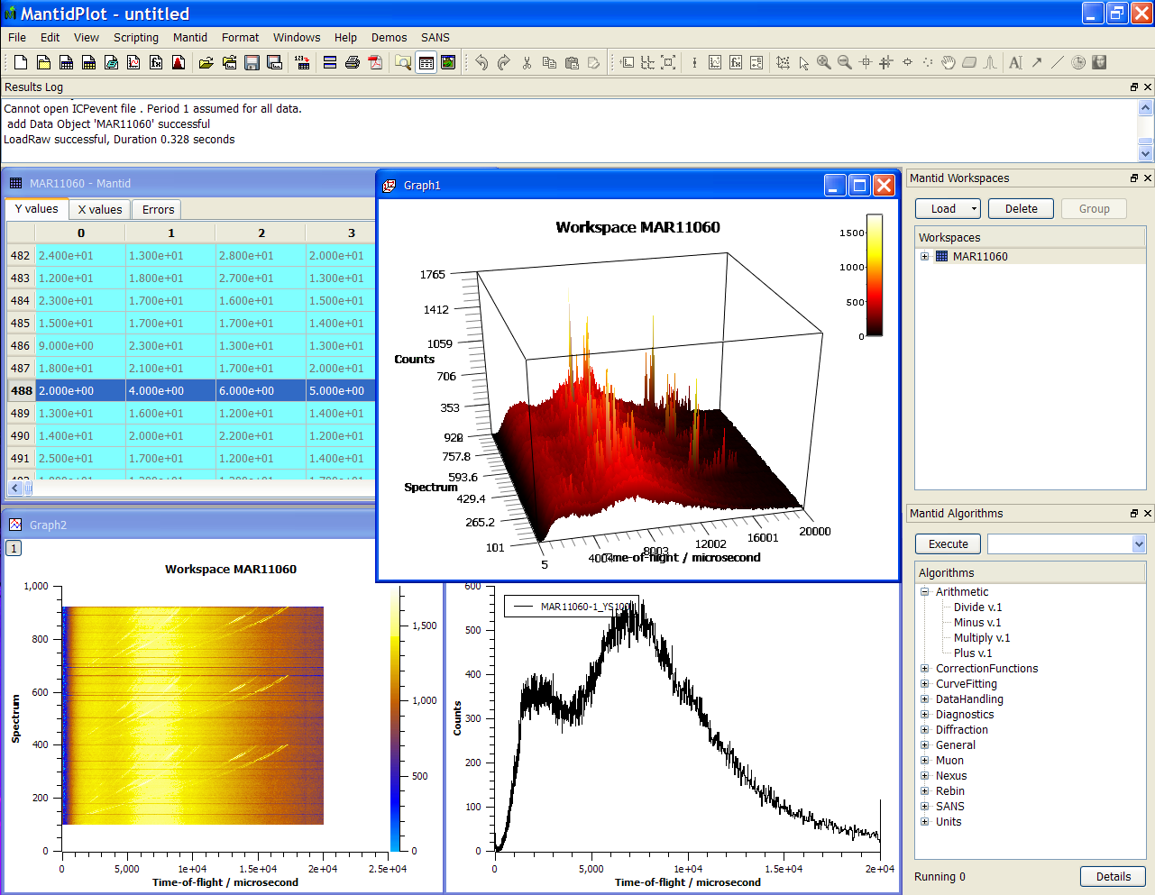
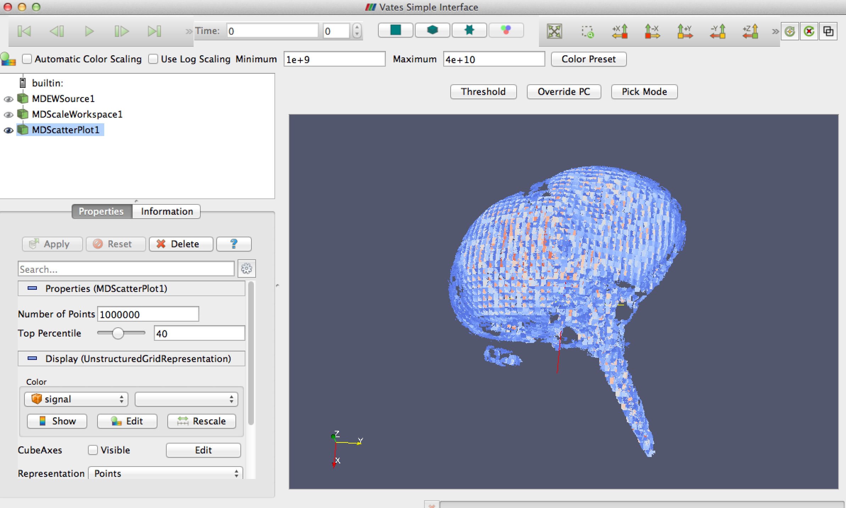
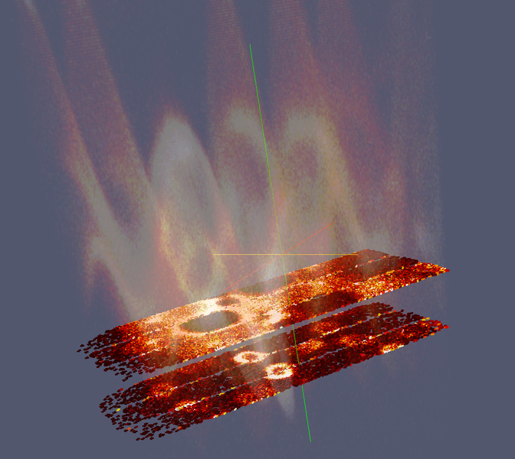
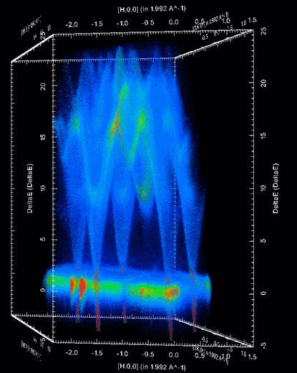

Document Control
This document is under document control. All members of the distribution list will receive updated copies whenever alterations are made. All other copies are uncontrolled.

Contributors
Name | Role | Company
Nicholas Draper | Author | Tessella

Document Approval
Name | Role | Company

Distribution
Name | Role | Company
Project Management Board Members | Recipient | Mantid Partnership
Mantid Project Repository | Filing | Mantid Partnership

Revision History
Author | Issue | Date | Description
Nicholas Draper | V1.R1.M0 | 225/01/2019 | 1st version written

References
Document | Ref | Date | Details and Version
Project Specification | [PS] |  | https://github.com/mantidproject/documents/blob/master/Project%20Management/ProjectSpecification.doc?raw=true
Stakeholder Plan | [SP] |  | https://github.com/mantidproject/documents/blob/master/Project%20Management/StakeholderPlan.doc?raw=true
Risk Register | [RR] |  | https://github.com/mantidproject/documents/blob/master/Project%20Management/RiskRegister.xls

Table of Contents
1 Introduction 3
2 Project Documentation 4
3 Project Status 4
4 User/Developer meeting 5
5 Areas for further collaboration 5
6 Usage of Mantid in various Environments 6
7 Future Release Dates 9
8 Appendix A: Metrics 10

Introduction

Purpose of this Document
This report details the current state of the Mantid project. The project management board will use this report as an item for discussion at the meeting.

Scope of this Document
The scope of this document is limited to the Mantid project, both for progress up to the meeting of the Project management board, and plans for the future.

Project Documentation
The project documentation is available through the links below. The documents have not been changed since the last PMB meeting.

Stakeholder Plan:
https://github.com/mantidproject/documents/blob/master/Project-Management/Stakeholder%20Map.doc?raw=true
Reviewed, No changes this time.

Risk Register:
https://github.com/mantidproject/documents/raw/master/Project-Management/RiskRegister.xls
Reviewed, No changes this time.

Project Status

Development Progress
Since the last PM report following our agreement to continue development on a longer release there has not been a full release of Mantid, we did however perform a set of development testing (similar to that at the start of a normal release process), and as a result of that we provided an “approved nightly“ build for those that needed a stable interim release on the 22-01-2019.

The next release 4.0 is currently planned for the 25th of March, with the following release plan:
- Code Freeze: 1st March
- Beta Test: 6th - 19th of March

Development for this release has encountered a few problems, with shortages and resignations in the ISIS team, and a number of communication difficulties that lead to significant delays to the development of the new Muon GUI. These have now been resolved with additional short term effort added to the team while longer term recruitment progresses.
One of the resignations was Keith, who was supporting testing, user support and documentation. This has proven to be a valuable role at ISIS, giving the instrument and visiting scientists better and faster support for their questions and issues as well as following up crashes and improving overall stability. We are looking to recruit a replacement at the moment.
Given the number of changes already in place in the team and the anticipated upcoming people to join, we have seen and anticipate development velocity to be impacted while new staff are inducted.
Mantid 4 development is progressing, we have demoed it to instrument scientist at ISIS in January and it was received well. We are focussing on implementing those tools that will allow techniques to be fully supported and start adopting the new workbench. This means that certain techniques that require tools such as the sliceviewer will not be able to adopt the new workbench for this release will receive greater focus in future releases.

The project metrics in Appendix A.

User/Developer meeting

Draft User Meeting Agenda
http://www.mantidproject.org/Category:Users_Workshop_2019

Draft Developer Meeting Agenda
http://www.mantidproject.org/Category:Developer_Workshop_2019

Mantid Project Managers Team
Pete Peterson, Owen Arnold and I met to discuss the Project Management team. We did not have a representative from the ILL at the meeting as a candidate has not yet been proposed.
We discussed how we might make this work in a practical context and the areas of responsibility we suggest we add or change in addition to the ToR discussed at the previous meeting.

Meetings
We agreed that aligning meetings around releases (being 3/year) rather than a more arbitrary 4/year would make more sense to align tasks and effort across facilities, with a focus on standardisation and aligning efforts towards common solutions where practical.
Within those meetings we propose to discuss and agree:
- Release dates
- Project management and development practices
- Release plans for the next and subsequent releases
- Future significant requirements
- Resourcing levels (with actions to be implemented locally at facilities or raised to the PMB)

Common purpose and direction
Not every decision that will be discussed or made by the project manager’s team will need to apply to all contributing facilities, but some will and there will be a need for collective responsibility in these situations. For example Release dates and changes to development practices will need to be adhered to across all facilities. For decisions such as this then a majority vote will be required to agree the change, in the event of a tied vote then the current chair of the PMT will have the casting vote.

Resource Allocation
The meetings would also begin by each Local project manager sharing their local requirements and priorities, followed by a process to align those requirements. It will only be possible to align requirements if each local project manager has the delegated authority to both change the relative priority of tasks and the allocation of development resource in order to allow for collaborative developments.
For example:
If ISIS has an urgent need for a new complex correction for a technique, with a deadline of 6 months. Other facilities are interested in developing something similar, but it is not a priority for at least 12 months.
This is a fairly common scenario. A sensible collaborative approach would be to lead the effort from ISIS, but to actively involve developers from the other facilities to help direct, develop and test the work for their facilities.
We propose that All Local project managers have the authority to assign developers onto shared tasks like this (informing the Instrument scientists) in situations where that does have a material impact on facility operations or delay planned experiments.
Given the need for discussion and alignment across four facilities it is important that the local project managers have a clear understanding of the resources available to them, their flexibility and the authority to make decisions in the meeting.

Core team interaction with the PMT
We suggest that core team proposals be initially discussed by the PMT before being presented to the PMB.
Furthermore we suggest that the PMT be given delegated authority to authorise investigations and developments involving less up to 3 man months per facility. These would be reported at the next PMB, but could be started under that delegated authority.

TSC interaction with the PMT
The TSC and PMT need to work closely to direct the development of the project. We propose that one of the members of the PMT (not the current chair) be the chair of the TSC to ensure effective communication between the groups. All members of the PMT would be invited as optional observers to the TSC meetings, in order to better contribute into maintenance task planning etc.

Areas for further collaboration
At the last PMB Jon requested that we review all of the workflows and interfaces across Mantid at the various facilities, to highlight where and why we differ or have commonality across and within our supported facilities. That report and opportunities for greater harmonisation are in the report here:
https://github.com/mantidproject/documents/blob/master/Project-Management/PMB/Mantid%20CFT%20Similarities%20and%20Differences.docx?raw=true

Usage of Mantid in various Environments
We currently fully support the following environments:
- RHEL 7 64bit
- Windows 7+ 64 bit
- Ubuntu 16.04 64 bit
- Ubuntu 18.04 64 bit
- OS X 10.10+

Current Usage:
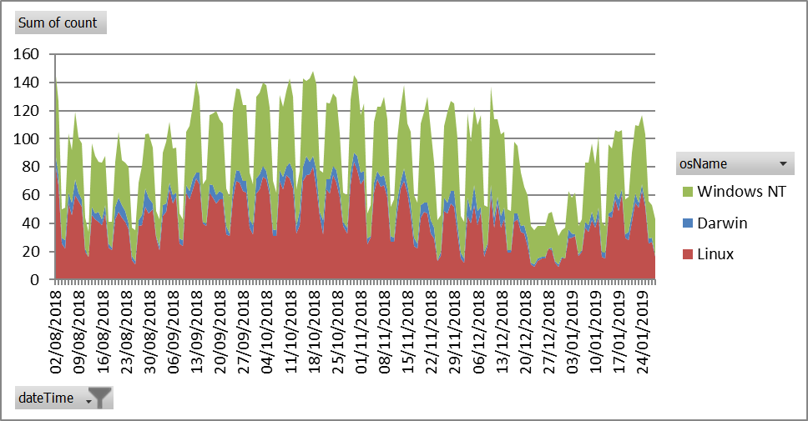

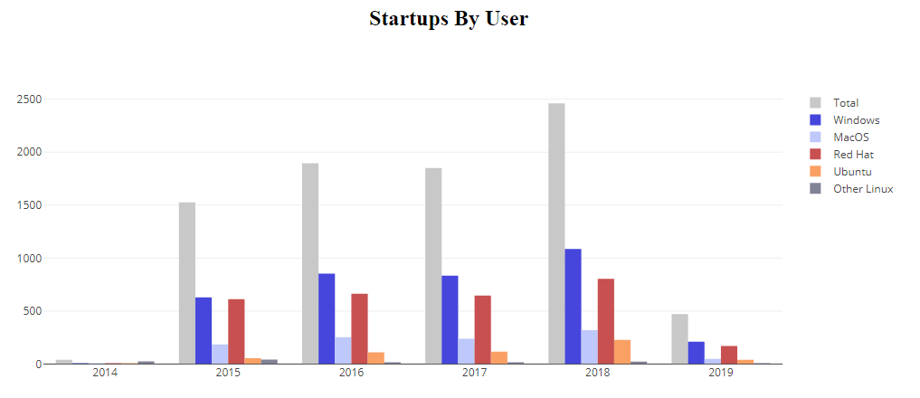
This graph shows the unique user count per year, the 2019 numbers are for the year so far.

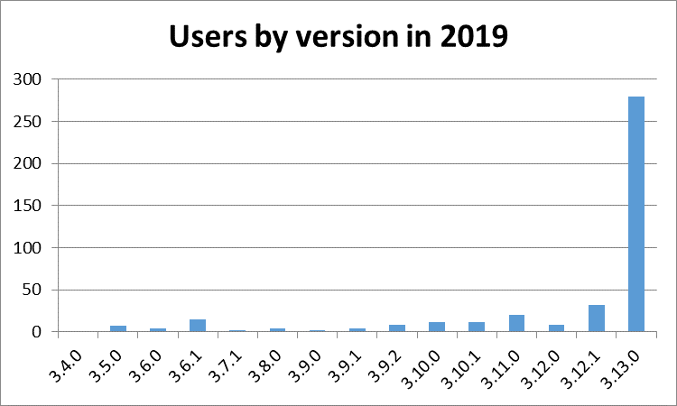
This is a view of the number of users that have used differenct versions of Mantid so far in 2019, This is not quite a month, so is a limited sample, but it shows Version 3.13.0 is the primary version used.
We have a significant tail of old versions, this is not a problem per se as long of the users of those versions do not need active support. Given the approach of visiting scientists leaving with a locally installed version then this is to be expected as they are unlikely to upgrade from the version that works for them.

Error Reporting
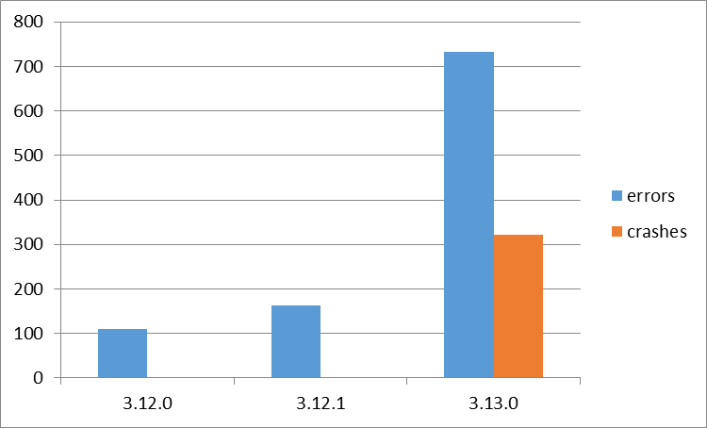
This graph shows both the raw numbers or errors and crashes sent through error reporting for each version. Our experince and the feedback we are getting from our users is that the increase in 3.13 is due to more issue being reported, rather than Mantid being less stable. For the sake of this graph they are defined as:
- Errors – Problems that caused the ast chance error dialog within Mantidplot to appear.
- Crashes – Problems where Mantidplot exited impropoerly, this can include situations where it is terminated because it has hung.
Crash reporting was only introduced in release 3.13.0, so these occaisions went unreported in previous versions

Future Release Dates
Rough initial dates:
- v4.1 22nd July 2019
- v3.16 18th November 2019

Appendix A: Metrics

Project Metrics
The code metrics are independently generated and displayed here
http://www.openhub.net/p/Mantid/analyses/latest/languages_summary

Total Lines : | 2,364,937 |  | Code Lines : | 1,692,887 |  | Percent Code Lines : | 71.6%
Number of Languages : | 17 |  | Total Comment Lines : | 378,501 |  | Percent Comment Lines : | 16.0%
 |  |  | Total Blank Lines : | 293,509 |  | Percent Blank Lines : | 12.40%

Code, Comments and Blank Lines
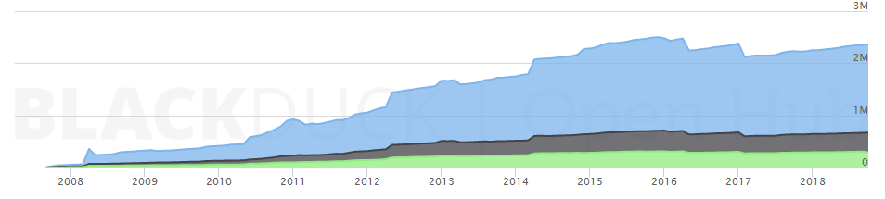
Code
Comments
Blanks

In a Nutshell, Mantid...
- has had 95,954 commits made by 158 contributors representing 1,692,887 lines of code
- is mostly written in C++ with an average number of source code comments
- has a well established, mature codebase maintained by a very large development team with stable Y-O-Y commits
- took an estimated 485 years of effort (COCOMO model) starting with its first commit in April, 2007

